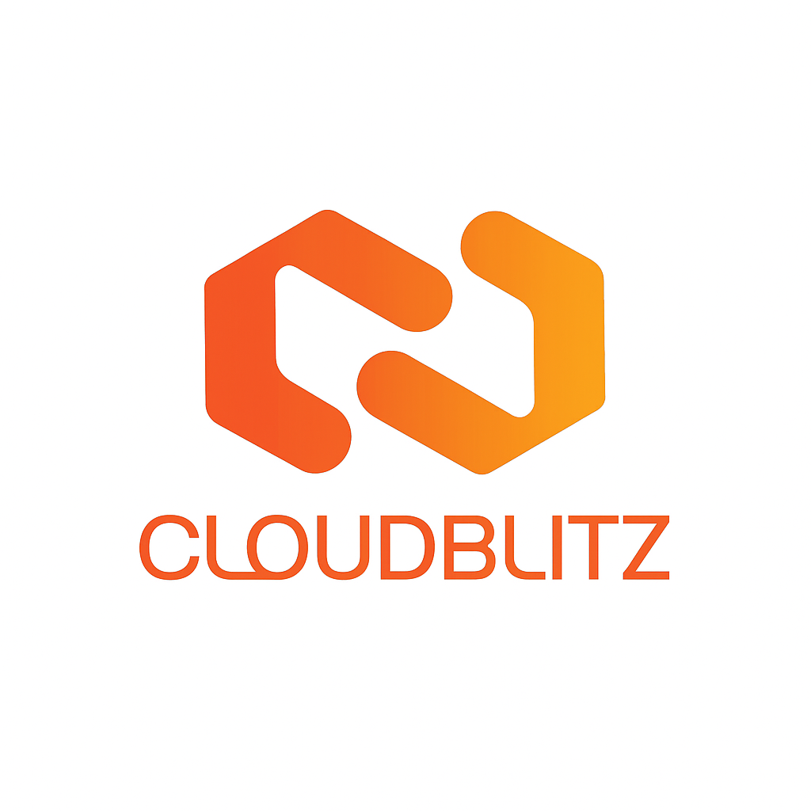DevOps Day 1
1. Introduction to Software Industry
The software industry focuses on designing, developing, and maintaining software applications. It includes companies that build programs for computers, mobile devices, and the internet. Software can be system software (like operating systems) or application software (like web or mobile apps). The industry is driven by technology innovation, automation, and digital transformation in almost every field.

2. Introduction to API, Its Types, and Use Cases
API (Application Programming Interface) is a set of rules that allows one software application to communicate with another. It helps developers connect different systems or services easily without needing to understand the internal code.
- Types of APIs:
- • Open/Public API – Available for everyone (e.g., Google Maps API).
- • Internal/Private API – Used within an organization only.
- • Partner API – Shared with specific business partners.
- • Composite API – Combines multiple APIs into one call.
- Common Use Cases:
- • Connecting frontend to backend services.
- • Payment integrations (e.g., Razorpay, PayPal).
- • Social media login or data sharing.
- • Weather, maps, or stock data fetching.

3. What is Frontend vs Backend
Frontend is the visible part of an application that users interact with — also called the client side. It includes web pages, buttons, forms, and visuals built using HTML, CSS, and JavaScript.
Backend is the hidden part of an application that handles data processing, server logic, and database communication — also called the server side. It’s built using languages like Python, Java, PHP, or Node.js.
- Example:
- • When you fill a form on a website (frontend) and submit it, the data goes to the server (backend) for processing.

4. Stages of Application Development
Application development involves multiple teams and stages to ensure quality software delivery.
Main Stages:
- Requirement Gathering – Understanding what the client needs.
- Design – Creating the app’s structure, UI design, and architecture.
- Development – Developers write code for both frontend and backend.
- Testing – Testers check for bugs, performance issues, and security.
- Deployment – DevOps team moves the application to servers or cloud for users to access.
- Maintenance – Regular updates, bug fixes, and improvements after launch.
- Team Roles:
- • Developer – Builds and codes the application.
- • Tester/QA – Ensures the app works correctly.
- • Database Admin (DBA) – Manages and optimizes databases.
- • DevOps Engineer – Handles deployment, automation, and cloud setup.
Agile vs Waterfall: Key Differences
Here’s a simple comparison between Agile and Waterfall models:
Aspect | Agile | Waterfall
Approach | Iterative and incremental process. | Sequential and linear process.
Flexibility | Highly flexible; changes can be made anytime. | Rigid; changes are difficult after initial planning.
Testing | Testing is done continuously throughout the project. | Testing is done only after development is completed.
Customer Involvement | High involvement; customers give feedback in every iteration. | Limited involvement; customer feedback comes after the project is finished.
Delivery | Small, working pieces delivered regularly. | Final product delivered at the end.
Best Suited For | Projects with changing requirements. | Projects with clearly defined and fixed requirements.

